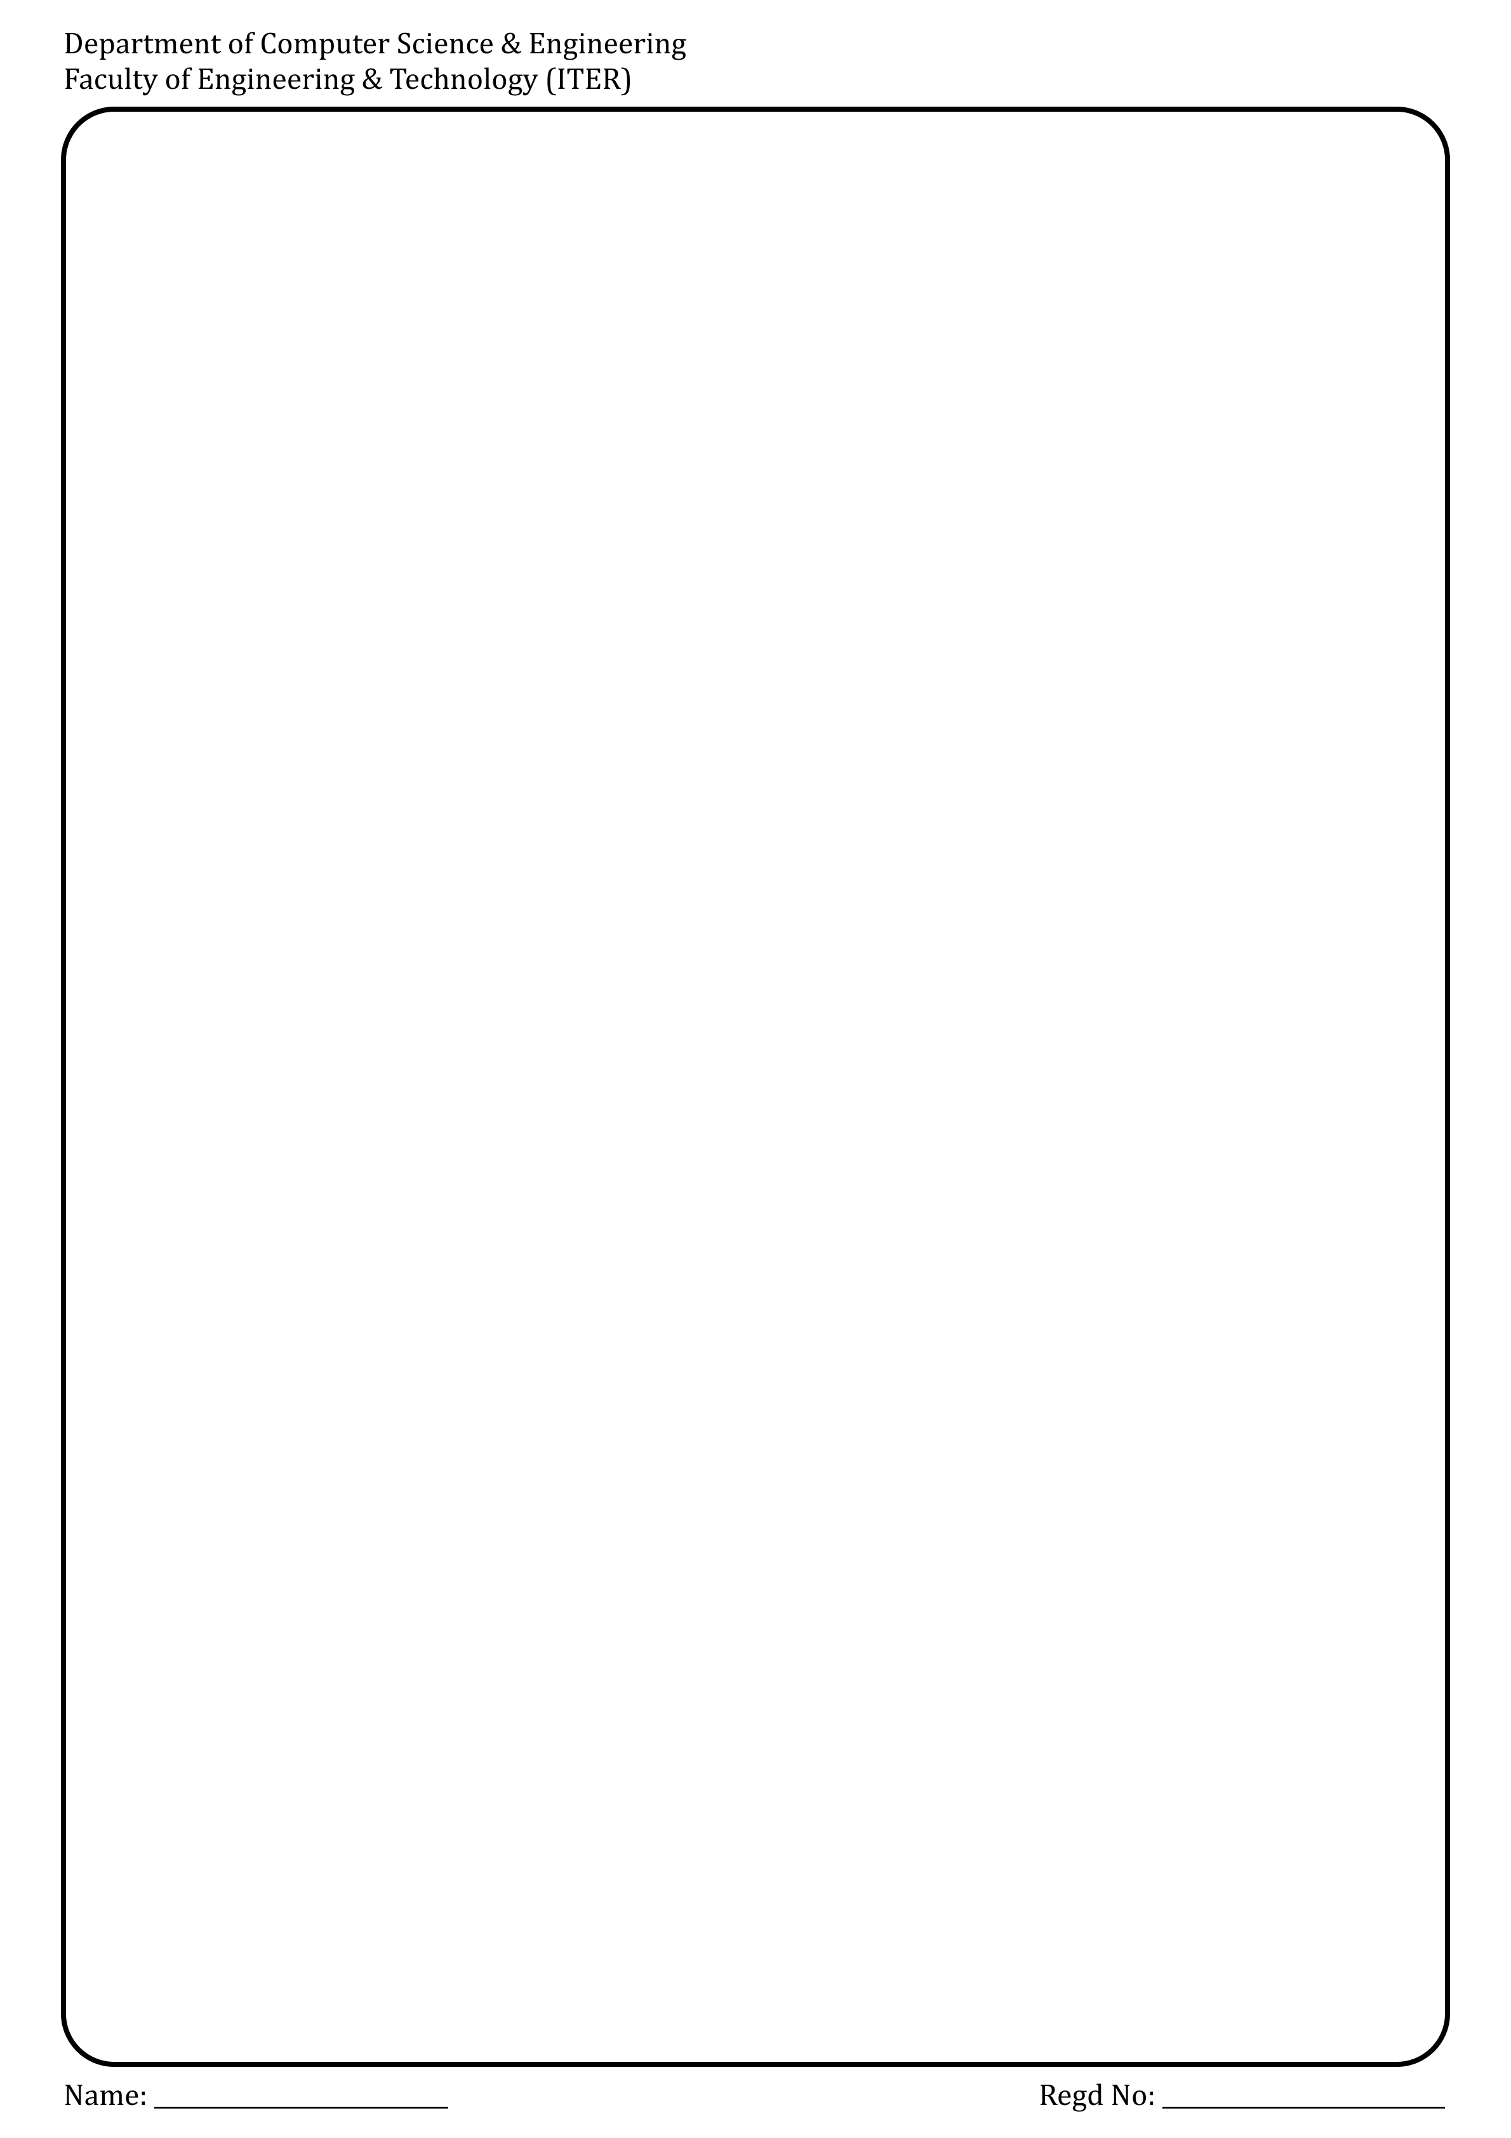

# Initial Permutation Table

IP = [58, 50, 42, 34, 26, 18, 10, 2,

60, 52, 44, 36, 28, 20, 12, 4,

62, 54, 46, 38, 30, 22, 14, 6,

64, 56, 48, 40, 32, 24, 16, 8,

57, 49, 41, 33, 25, 17, 9, 1,

59, 51, 43, 35, 27, 19, 11, 3,

61, 53, 45, 37, 29, 21, 13, 5,

63, 55, 47, 39, 31, 23, 15, 7]

# Final Permutation Table

FP = [40, 8, 48, 16, 56, 24, 64, 32,

39, 7, 47, 15, 55, 23, 63, 31,

38, 6, 46, 14, 54, 22, 62, 30,

37, 5, 45, 13, 53, 21, 61, 29,

36, 4, 44, 12, 52, 20, 60, 28,

35, 3, 43, 11, 51, 19, 59, 27,

34, 2, 42, 10, 50, 18, 58, 26,

33, 1, 41, 9, 49, 17, 57, 25]

# Expansion Table

E = [32, 1, 2, 3, 4, 5,

4, 5, 6, 7, 8, 9,

8, 9, 10, 11, 12, 13,

12, 13, 14, 15, 16, 17,

16, 17, 18, 19, 20, 21,

20, 21, 22, 23, 24, 25,

24, 25, 26, 27, 28, 29,

28, 29, 30, 31, 32, 1]

# S-boxes

S_BOXES = [

[[14,4,13,1,2,15,11,8,3,10,6,12,5,9,0,7],

[0,15,7,4,14,2,13,1,10,6,12,11,9,5,3,8],

[4,1,14,8,13,6,2,11,15,12,9,7,3,10,5,0],

[15,12,8,2,4,9,1,7,5,11,3,14,10,0,6,13]],

[[15,1,8,14,6,11,3,4,9,7,2,13,12,0,5,10],

[3,13,4,7,15,2,8,14,12,0,1,10,6,9,11,5],

[0,14,7,11,10,4,13,1,5,8,12,6,9,3,2,15],

[13,8,10,1,3,15,4,2,11,6,7,12,0,5,14,9]],

[[10,0,9,14,6,3,15,5,1,13,12,7,11,4,2,8],

[13,7,0,9,3,4,6,10,2,8,5,14,12,11,15,1],

[13,6,4,9,8,15,3,0,11,1,2,12,5,10,14,7],

[1,10,13,0,6,9,8,7,4,15,14,3,11,5,2,12]],

[[7,13,14,3,0,6,9,10,1,2,8,5,11,12,4,15],

[13,8,11,5,6,15,0,3,4,7,2,12,1,10,14,9],

[10,6,9,0,12,11,7,13,15,1,3,14,5,2,8,4],

[3,15,0,6,10,1,13,8,9,4,5,11,12,7,2,14]],



[[2,12,4,1,7,10,11,6,8,5,3,15,13,0,14,9],

[14,11,2,12,4,7,13,1,5,0,15,10,3,9,8,6],

[4,2,1,11,10,13,7,8,15,9,12,5,6,3,0,14],

[11,8,12,7,1,14,2,13,6,15,0,9,10,4,5,3]],

[[12,1,10,15,9,2,6,8,0,13,3,4,14,7,5,11],

[10,15,4,2,7,12,9,5,6,1,13,14,0,11,3,8],

[9,14,15,5,2,8,12,3,7,0,4,10,1,13,11,6],

[4,3,2,12,9,5,15,10,11,14,1,7,6,0,8,13]],

[[4,11,2,14,15,0,8,13,3,12,9,7,5,10,6,1],

[13,0,11,7,4,9,1,10,14,3,5,12,2,15,8,6],

[1,4,11,13,12,3,7,14,10,15,6,8,0,5,9,2],

[6,11,13,8,1,4,10,7,9,5,0,15,14,2,3,12]],

[[13,2,8,4,6,15,11,1,10,9,3,14,5,0,12,7],

[1,15,13,8,10,3,7,4,12,5,6,11,0,14,9,2],

[7,11,4,1,9,12,14,2,0,6,10,13,15,3,5,8],

[2,1,14,7,4,10,8,13,15,12,9,0,3,5,6,11]]

]

# Permutation Function P

P = [16, 7, 20, 21,

29, 12, 28, 17,

1, 15, 23, 26,

5, 18, 31, 10,

2, 8, 24, 14,

32, 27, 3, 9,

19, 13, 30, 6,

22, 11, 4, 25]

# PC-1 for key permutation

PC1 = [57,49,41,33,25,17,9,

1,58,50,42,34,26,18,

10,2,59,51,43,35,27,

19,11,3,60,52,44,36,

63,55,47,39,31,23,15,

7,62,54,46,38,30,22,

14,6,61,53,45,37,29,

21,13,5,28,20,12,4]

# PC-2 for key compression

PC2 = [14,17,11,24,1,5,

3,28,15,6,21,10,

23,19,12,4,26,8,

16,7,27,20,13,2,

41,52,31,37,47,55,

30,40,51,45,33,48,

44,49,39,56,34,53,

46,42,50,36,29,32]

# Number of left shifts

SHIFT = [1, 1, 2, 2, 2, 2, 2, 2,

1, 2, 2, 2, 2, 2, 2, 1]

# Helper functions

def permute(block, table):

return [block[i-1] for i in table]

def shift_left(k, n):

return k[n:] + k[:n]

def xor(a, b):

return [i ^ j for i, j in zip(a, b)]

def sbox_substitution(block48):

output = []

for i in range(8):

chunk = block48[i*6:(i+1)*6]

row = (chunk[0] << 1) | chunk[5]

col = (chunk[1] << 3) | (chunk[2] << 2) | (chunk[3] << 1) | chunk[4]

val = S_BOXES[i][row][col]

bin_val = [int(x) for x in format(val, '04b')]

output.extend(bin_val)

return output

def generate_keys(key64):

key56 = permute(key64, PC1)

C = key56[:28]

D = key56[28:]

keys = []

for i in range(16):

C = shift_left(C, SHIFT[i])

D = shift_left(D, SHIFT[i])

combined = C + D

round_key = permute(combined, PC2)

keys.append(round_key)

return keys

def des_round(L, R, key):

expanded_R = permute(R, E)

temp = xor(expanded_R, key)

sbox_out = sbox_substitution(temp)

permuted = permute(sbox_out, P)

result = xor(L, permuted)

return R, result

def des_encrypt(block64, keys):

block = permute(block64, IP)

L, R = block[:32], block[32:]

for i in range(16):

L, R = des_round(L, R, keys[i])

final_block = R + L # Note the swap

return permute(final_block, FP)

def des_decrypt(block64, keys):

block = permute(block64, IP)

L, R = block[:32], block[32:]

for i in range(15, -1, -1):

L, R = des_round(L, R, keys[i])

final_block = R + L # Note the swap

return permute(final_block, FP)

# Convert string to 64-bit binary

def string_to_bitlist(s):

return [int(bit) for char in s for bit in format(ord(char), '08b')]

# Convert 64-bit binary to string

def bitlist_to_string(b):

return ''.join(chr(int(''.join(map(str, b[i:i+8])), 2)) for i in range(0, len(b), 8))

# Example usage

plaintext = "ABCDEFGH" # 8 characters = 64 bits

keytext = "12345678" # 8 characters = 64 bits

plain_bits = string_to_bitlist(plaintext)

key_bits = string_to_bitlist(keytext)

subkeys = generate_keys(key_bits)

cipher_bits = des_encrypt(plain_bits, subkeys)

decrypted_bits = des_decrypt(cipher_bits, subkeys)

print("Original:", plaintext)

print("Encrypted bits:", cipher_bits)

print("Decrypted:", bitlist_to_string(decrypted_bits))

Output: -

Original: ABCDEFGH

Encrypted bits: [1, 0, 0, 1, 0, 1, 1, 0, 1, 1, 0, 1, 1, 1, 1, 0, 0, 1, 1, 0, 0, 0, 0, 0, 0, 0, 1, 1, 1, 1, 1, 0, 1, 0, 1, 0, 1, 1, 1, 0, 1, 1, 0, 1, 0, 1, 1, 0, 0, 0, 1, 0, 0, 1, 0, 1, 0, 1, 1, 0, 1, 1, 1, 1]

Decrypted: ABCDEFGH

